2026
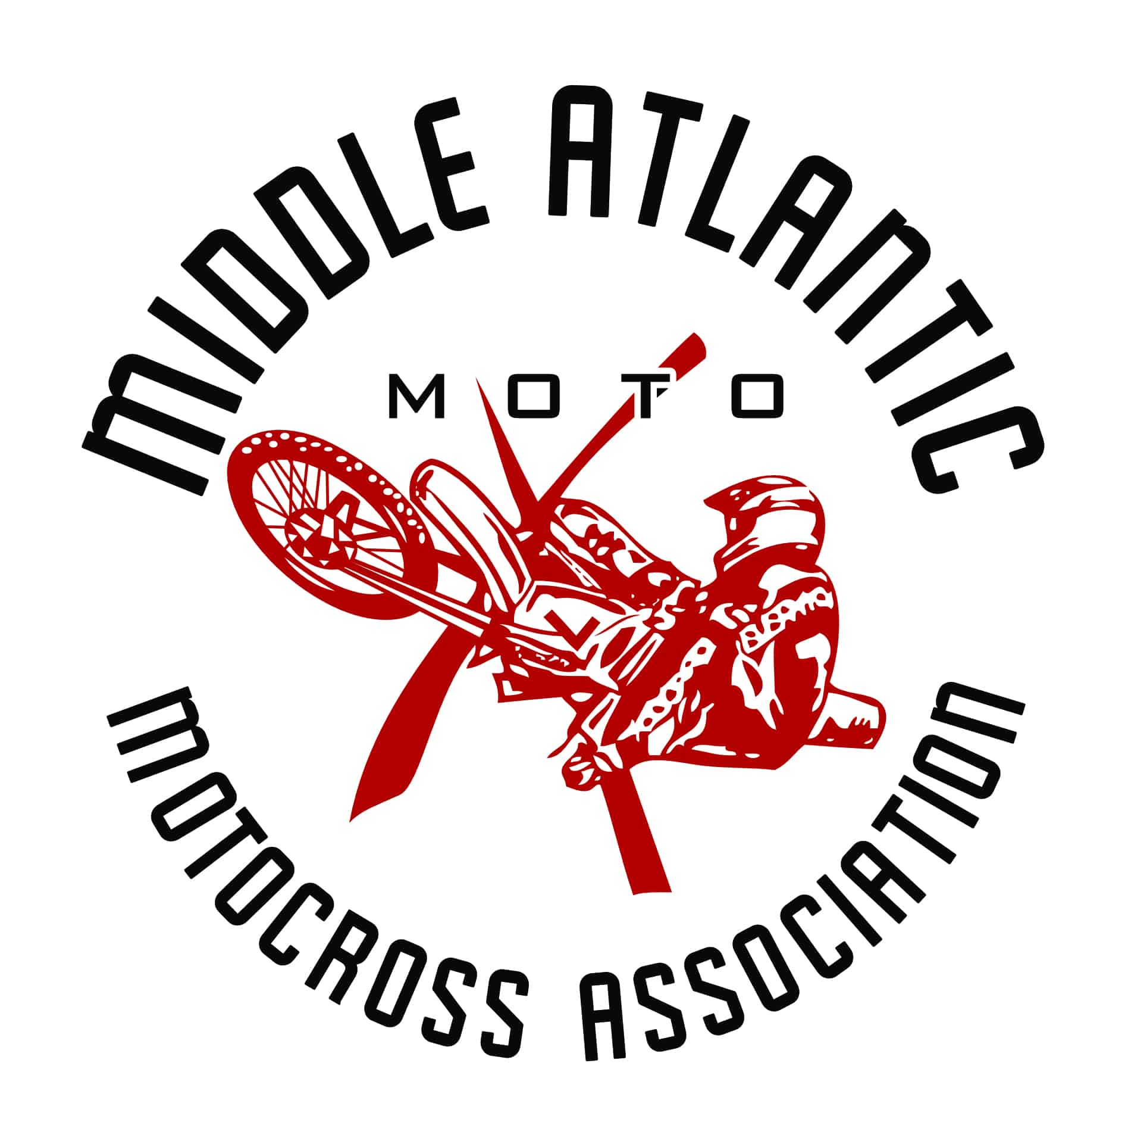
RULES OF COMPETITION
11----------------------1-----------------------
-----------

1975-2026
51 Years of Youth Motocross
WWW.MAMAMX.COM

MIDDLE ATLANTIC MOTOCROSS ASSOCIATION
“M.A.M.A.”
2026 is the 51st season for MAMA, a non-profit youth motocross organization.
The organization is run by an all-volunteer Board of Directors and is dedicated to providing the very best in youth motocross racing.
Throughout this racing season, the Board hopes that all members will learn and grow as a result of the time spent at our events. MAMA races are known nationwide for the high-quality standards upheld.
Sportsmanship, caring, understanding, and fairness are traits we all should foster, and are priorities at MAMA. By providing the youth of our area the safest, most organized motocross races possible, we invest in today's youth in hopes for a better tomorrow.
The rules of competition are intended only as a guide for the conduct of the sport, pursuant to uniform rules. Rules related to safety are made to make everyone concerned with safety. Moreover, each participant in competition has the responsibility to assess the safety aspects of facilities and conditions and must assume the risk of competition.
All races are sanctioned through the AMA.
MAMA…Racing into the future.

TABLE OF CONTENTS
2026 Fees ……………………………………………………………………..4
2026 MAMA Board of Directors …………………………………………..5
Board Nominations ………………………………………………………...5
Official Duties and Powers ………………………………………………...6
Riders and Eligibility ………………………………………………………..7
Meet and Entrant Rules …………………………………………………….8
Violation Matrix ……………………………………………………………..13
Pit Vehicles ………………………………………………………………….14
Protests, Claiming and Offenses ………………………………………..15
Equipment …………………………………………………………………...15
Rider Classification ………………………………………………………..16
Number Plate Colors ……………………………………………………....16
Rider Performance Value (RPV) ………………………………………….17
Points System Schedule …………………………………………………..19
Trophy Schedule …………………………………………………………....19
Payout Schedule ….…………………………………………………………19
Year End Payouts ...…………………………………………………………21
Official Flags …………………………………………………………………22
2026 MAMA 50cc Class Structure…….…………………………………..22
2026 MAMA Class Structure (Saturday & Sunday)...…...……………..23
Track Information …………………………………………………………...24
2026 MAMA Schedule ………………………………………………………26
Sample Minor Authorization ………………………………………………27

2026 FEES
Item | Fee(s) | Notes
Gate Fees | Gate fees will be determined by each track. Please check the MAMA Race Flyer on the Facebook page, Instagram page or the track website for specific information. | PLEASE NOTE that Gate fees are non-refundable.  Whether you arrive Friday, Saturday or Sunday, you will be required to pay a gate fee. If a rider is under 12, you must still pay gate fees – all members of your party must be signed in on the waiver forms at the gate by an adult.
MAMA Membership Card  (Good for 2026 Season) | $35/year- if purchase before 1st race (3/21/26)  $40/year- if purchased after 3/21/26  $10/race day for one-day pass | An annual MAMA membership is required if you would like to be considered for year-end awards and pay-out.  Membership is required to race. If you do not want to purchase an annual membership, a one-day membership can be purchased for $10 per race day.
MAMA Non-Racer  Membership | $10 | This will allow you to continue your longevity with MAMA in the event you are unable to race. It also allows for your participation in voting for board members.
AMA Membership  Card  A valid AMA  membership  is REQUIRED for  anyone who signs up to practice or race. | $49/year Adult  $20/year Youth  $119/year Family  $25 for a one-day AMA membership | Visit the AMA website to renew or apply for a new AMA membership- www.amadirectlink.com. If you apply over the internet, please print out a copy of the confirmation and bring it with you to the track until you receive your new AMA card. If you renew your card and the AMA assigns you a new member number, please be sure to let us know so your points can be combined.
Race Fees | Sign up fees for Payback classes will be determined by each track. Please check the MAMA Race Flyer on the Facebook page, Instagram page or track website for specific information.  A Classes  250 A, 450 A,30+ A, 40+ A- 100% Payout  25+ and 50+ - 80% Payout for A riders ONLY | Sign up online, prior to the race weekend. Online sign-ups will be available for some races based on the track preferences. Information will be available for each race on the MAMA flyer.  OR  Sign up in person on Saturday afternoon or Sunday morning. Please check the MAMA race flyer on Facebook, Instagram or website for specific information.  Racers MUST have a 2026 AMA card and a 2026 MAMA Membership to race.  Please be sure to BRING YOUR RIDER TO SIGNUP WITH YOU. This is an AMA rule.  Payout classes - No Rain Checks or Points Cards can be used for signup – NO rain checks will be issued for these classes – NO EXCEPTIONS.
Practice Fee | Saturday practice fees will be determined by each track. | Sign-up to practice can be made during sign-up hours only. Must hold a valid AMA card.
Transponder Rental Fee | Transponder rental fees will be determined by each track. | MAMA uses transponders for electronic scoring. In order to race, you will need to have a transponder. A deposit (cash or credit card), determined by the track or your driver’s license will be held when you rent a transponder – it will be returned when you return the transponder at the end of your race day.
Returned Check Fee | $25

Important Phone Numbers
Membership: 410-688-7652; membership@mamamx.com

2026 BOARD OF DIRECTORS
Name, Office, Term Expiration & Contact Info
President
Timothy Gately 2027; president@mamamx.com
Vice President
Todd Galbraith 2026; vicepresident@mamamx.com
Secretary
Jackie Sebring 2027; secretary@mamamx.com
Treasurer
Steph Galbraith 2026; treasurer@mamamx.com
Sponsorship & Events Coordinator
Deanna Gately 2026; sponsorships@mamamx.com; events@mamamx.com

Directors
Chandler Ellis 2026
Jason Galbraith 2026
John Kernana 2027
Sarah Potter 2027
Joe Schueler 2026
Matt Schueler 2027
If you have any questions, please feel free to see any one of the Board Members listed above. Your “neighbors” at the track are also a good source of information.... the motocross family is like no other when it comes to helping each other out – so just ask and someone will be glad to help you or point you in the right direction to get what you need.
BOARD NOMINATIONS
Pursuant to the MAMA AMENDED AND RESTATED BY-LAWS, the nomination process for expiring terms is as follows:
Officers and Director positions with expiring terms will be nominated by the members by ballot at the 8th race of the season.
Officers shall be elected by ballot by a majority vote of the current MAMA Board of Director at the 9th race of the season.
Directors shall be elected by ballot by a majority vote of the members at the 9th and 10th race of the season.

OFFICIAL DUTIES AND POWERS
A. Referee: The head referee will be hired by each track. The Referee shall be set as general supervisor of the race but shall not attempt to carry out the duties of any other official of the Association.
*In the case there is no head referee, the President and Vice President will make final decisions.
The duties of the Referee shall include the following:
1. Receive all protests and render decisions thereon.
2. Render all decisions on disqualification of riders and disqualify any rider who violates any of the rules of the meet of the Association.
3. Give complete instructions on the starting rules to all riders. This shall include information on the flags.
4. Determine if scorers, timers, umpires, flagmen, etc., are ready and in place before starting the meet.
5. The Referee is also empowered to measure the motor displacement of all place winners, (not an individual motor unless protested), in any meet held under Association sanction. The Referee reserves the right to designate another person to measure motor displacement. Any rider refusing to allow his/her motor for measurement automatically disqualifies himself/herself for that day's meet. AMA penalty for this is a 1-year suspension.
B. Scorer (as required):
The duties of the Scorers shall include the following:
1. Exhibit a list of all events.
2. Keep a complete record of moto finishes in all events and administer points.
3. Provide a scoring station at the proper place on the course.
4. Ensure all necessary materials are provided for proper scoring.
5. Advise the Referee when scorers are ready.
C. Membership Administrator:
The duties of the Membership Administrator shall include the following:
- Receive all entries and check rider's membership cards at race sign-up.
- Issue membership cards for any new members that have registered online.
- Maintain database information of current members.

RIDERS AND ELIGIBILITY
A. All riders in MAMA sanctioned events are required to hold a valid AMA membership. All riders that wish to be eligible for year-end awards must also be members of MAMA. Only MAMA members will receive points towards year-end awards. Membership in MAMA is for the calendar year January 1st to December 31st. A youth member's age as of January 1st of the race year will determine the age group for racing. A rider may move up to an older age classification if the rider is going to turn that age in the current year, but may not return to the younger class. A rider may not run two different age groups on the same day.

1. To be eligible for year-end awards, a rider must compete in 2/3rds of the total number of races for that season in that particular class.
2. Each rider will be required to “drop” one race from their year-end points.
A. Parent, legal guardian or authorized adult must be present at sign-up and remain present at all times during participation in any MAMA sanctioned event. An “Authorized Adult” is any person 18 years of age or over, including the parent or legal guardian who is given the responsibility of a minor on a given day. If this person is not the parent or legal guardian, two notarized letters giving the responsibility of the minor must be brought to sign-up (one to turn in at signup – and one to hold in case the rider needs to be transported to a medical facility). The guardianship must be RACE and DATE specific, signed by both parents or guardians, AND NOTARIZED. Please see a sample of the acceptable letter, approved by the AMA, to be used when signing up a child for whom you are not the parent or legal guardian at the back of this book. The rider must also have a minor release form signed and notarized by both parents, or an AMA Annual Minor Release Card.
1. A NOTARIZED AUTHORIZATION (see above) SIGNED BY THE RIDER'S PARENTS OR LEGAL GUARDIAN IS MANDATORY FOR EACH RACE IF THE PARENT OR LEGAL GUARDIAN IS NOT PRESENT.
2. Proof of ID may be required at sign-up.
3. It is the rider's duty to enter the class in which it is legal for him/her to ride. ENTRY INTO A CLASS DOES NOT NECESSARILY MAKE A RIDER LEGAL FOR THAT CLASS. An entrant can be protested by another entrant for riding in the wrong class. Responsibility for meeting specifications rests with the individual rider. Knowingly signing up for a class in which you are not legal to ride may result in suspension of your AMA card. Check the AMA websitehttps://americanmotorcyclist.com/racing/racing-resources/advancement-and-appeal/to see if you or your rider advanced after the 2025 MAMA season.
If you ride a 125cc or above in the 250 or Open classes, please double check the AMA website to see if you were advanced by the AMA: AMA Racer Advancement and Appeal - American Motorcyclist Association
Notice to Racers:
- Riders who are aware of specific errors in the results reported to AMA Racing, resulting in a mistake in their classification advancement, are encouraged to bring those specific errors to the attention of AMA Racing. In the case of erroneous results, e-mail the following information to mxadvance@ama-cycle.org:
Name
AMA number
Rider status and date advanced shown in Motocross Results Center
Daytime phone number
E-mail address
The details of the specific error
B. No distinction of events or activities shall be made upon the basis of race, color, creed, sex or national origin. All participants in activities shall compete under the same rules and in the appropriate classes as determined herein.
C. The rider should be of sufficient size to be able to maintain safe and proper stability and control of the machine at all times. This includes stopping or other such items as it may be necessary to put one or both feet on the ground.
D. The MAMA Board shall have the responsibility and final authority to change a member's classification because of his/her abilities (ONLY APPLIES TO YOUTH AND BEGINNER CLASSES).
E. Immediate interpretation of the rules will be made by the Referee of the meet.
F. Rider (or their parent or guardian) is responsible for proof of age at all MAMA events. G. Absolutely no phone calls will be made to confirm authorization to sign for a rider.
FOR ANY RULES NOT COVERED ABOVE, PLEASE SEE THE 2026 AMA MOTOCROSS RULEBOOK
Motocross Rules - American Motorcyclist Association
MEET AND ENTRANT RULES
See the 2026 AMA Motocross Rulebook for all rules not listed below:
Special Note: The American Motorcyclist Association doesn't set engineering and design standards or inspect tracks used in AMA-sanctioned standard events. Participants are solely responsible for their safety at AMA-sanctioned meets and should assess their own ability to negotiate each individual track or course. Participants who doubt the competence of track officials, have concerns about the safety of the course, or their own ability to negotiate the course, or are uncertain about the condition of their vehicle, or doubt the competence of fellow competitors, should not participate and should request the return of their entry fee before competitive activity begins.
A. General Rules of the Meet
1. Every club, association, organizer, rider and all other persons participating in, or connected with, any meet are bound by these rules. Recognized districts must submit any supplementary rules to the AMA for approval.
2. No stylized jumping contests will be allowed before, during or after AMA sanctioned meets without approval from the AMA.
3. No gambling is permitted at any AMA-sanctioned meet, and it is the responsibility of the organizer and referee to strictly enforce this rule.
3. At any meet, except sidecar events, the following applies: The motorcycle must meet the class requirement for engine size. All classes need not be run at any given meet. However, all classes to be run must be listed on any advance advertisements.
4. At any meet if there are five or more entries for any class, that class must be run. If there are more than five but fewer than twelve riders in each of any two consecutive classes, these classes may be run at the same time (for separate prizes). In any advertised class with fewer than five entries, the class must be run, scored and awarded but may be combined with a similar ability or equipment class. Sidecar entries must be a minimum of six AMA members and three sidecars. Mini cycles and motorcycles may not race or practice on the track or course at the same time.
5. With AMA permission, a standard meet may run in conjunction with a professional meet. At meets where spectator admission is charged, an entry fee may be charged in addition to the admission fee.
6. At meets where the track is supplying medical insurance for the riders, they may collect an additional fee for this service. The track must
display at sign up a sign stating, Rider Medical Insurance Today, in 3-inch high letters. All other meets should be recognized as not having rider medical insurance.
7. In addition to the classes described in this rulebook, organizers may organize, advertise and conduct limited classes in any type of AMA competition. Limited motorcycles (as described in Section 1.2) are subject to inspection, and any deviation will result in the motorcycles being assigned to other categories or disqualified.
8. AMA Grand National-, Superbike- or Pro Expert-licensed riders aren't eligible to enter any Amateur National Championship meet.
9. A rider who earns a national number may begin using the number immediately and until the succeeding year’s event where the national number was earned.
B. Youth - General Rules of the Meet
WARNING: Motor vehicle mishaps, in competition or otherwise, can result in injury or death. Minors without parental consent or supervision should never use motor vehicles.
1. Youth meets must be conducted according to the rules in this rule book. Any variations aren't allowed without the written permission of AMA Racing.
2. All classes to be run at a meet must be listed in advance advertising and posted in a prominent place at the entry desk. All classes advertised must be run if there are five or more riders for that class.
3. When there are fewer than five riders per class, they may be advanced to the next higher class and scored separately. If there are more than five but fewer than ten riders in each of two consecutive classes, the two classes may be run at the same time (for separate points and trophies).
4. Two riders may use the same motorcycle, provided they are entered in different classes (e.g., an 85cc limited motorcycle ridden in the 9-11 class and 12-13 class) and the classes aren't advertised to be run together.
C. Race Rules
- On the day of a meet, only paid racers or practice participants may ride or practice on the racing course. Riding on the course is prohibited except during events and scheduled practice sessions.

- The motorcycle at the starting line for the rider’s first moto is considered the qualified motorcycle for the meet in that class. Only the motorcycle that is considered the qualified motorcycle will be allowed on the track for a sighting/parade lap. In any case, a rider is not allowed to switch motorcycles after the start of sighting/parade lap.

- A rider may use any referee approved device, such as blocks or small platforms, to raise the level of his/her feet at the start of an event so long as the device(s) are removed immediately after the start.

- Practice or warm up is limited to the designated area identified by the organizer. Competitors riding, or allowing their motorcycles to be ridden, outside these boundaries will be excluded from the meet.

- A rider must be ready when called to the starting area. Two minutes are allowed after the starters call to make minor repairs for mechanical issues.

- Except in a designated mechanic's area, no adjustments, repairs or refueling may be done during a moto. A rider, however, may do such work anywhere on the course without assistance and using only parts or tools he may be carrying himself. Once an event has started, any change of motorcycle is forbidden. A rider will be disqualified from the moto for disregarding this rule.

- A rider whose motorcycle becomes disabled before he/she reaches the finish line may, without assistance, push or carry the motorcycle (in the direction of the track) across the finish line to receive the checkered flag. At the referee's discretion, the rider may be instructed to leave the track at the nearest exit point and will be considered to have completed the event, provided he has completed at least 50 percent of the number of laps as the winner.

- If a rider stops for any reason during an event, he/she must restart without any outside assistance. However, if a rider falls, blocking the course and endangering other riders, he/she may receive help or have his/her motorcycle pushed off the course. The Referee may allow for outside assistance for 0-51cc class riders. For other mini cycle class riders, the referee may allow for outside assistance when adversely muddy conditions exist. In all cases, this must be done without interfering with competition. An attempt to help under any other situation will result in the rider's disqualification.

- A rider leaving the course must re-enter at the same point or at the first point where he/she can safely, without interfering with other riders and without gaining an advantage. A rider who fails to do so may be docked at least one finishing position for the moto at the discretion of the Referee. If a rider accelerates while off course or cuts large amounts of the racecourse, the rider may be determined to have gained an advantage without gaining a position.

- A competitor who rides in a way that endangers officials, other riders or the public will be subject to immediate disqualification from the meet by the Referee.

- When entering or leaving the pits, a rider must use designated entrance and exit lanes. Failure to do so may result in disqualification.

- The Referee may decide the maximum number of riders who start any event. Starting riders will be those who qualify as a result of time trials or qualifying heats. If heat races are used, a rider must start a heat to qualify for the final event.

- An event stopped by the referee before 60% of the race is completed (rounded down to the nearest whole number of laps) the race will be re-started from the beginning. Riders may make minor repairs and adjustments at the starting area only. Any race start or re-start will be considered an official part of the event. Therefore, any infraction will be deemed valid and ruled upon accordingly. An event stopped by the referee after 60% of the race is completed (rounded down to the nearest whole number of laps completed) the race will be considered complete and will be scored from the last completed lap scored prior to the red flag being displayed.

- No entrant will be eligible to enter more than four classes during a single day meet. For meets that run more than one day, riders may enter up to six classes.
D. Additional Rules:
- If a rider or its guests, pit crew, etc. has numerous offenses within any given area of this rule book, when on or off track, the incidents can and will be combined. You are responsible for all family members and crew members. If you, any family member, or any crew member repeatedly violate any of the rules stated herein, you and/or that family member or crew member will be subject to the following:
1st offense of any rule, you will be given a verbal warning by a board member, with at least one other board member present, and will receive the punishment stated for violating that rule
2nd offense by you, your family member, or your crew member of any rule, you will again be given verbal notice, followed by a certified letter mailed to your home outlining the first two offenses
3rd offense by you, your family member, or your crew member of any rule, you will be asked to leave the property for the remainder of that weekend's event. Please remember that once your wristband has been removed (which it will be in this case), and your gate fee refunded, you are considered trespassing and may be removed by law enforcement officials if you refuse to leave the property. After your removal from the track, you will receive a second certified letter at your home stating your penalty. The executive board may and will impose consequences for these infractions to include up to a one year ban from any MAMA event.
- Infractions of the rules on any day of a race weekend will be punishable by the standards set in the matrix in this document. The rider is responsible for all his family members. All decisions are at referees and executive board discretion and will be deemed final.

- The referee shall have the authority to declare a race complete after one moto when conditions warrant. Any class that is unable to complete their second moto will receive points based on their finish in the first moto only.

- There will be NO CASH REFUNDS after practice has started. If MAMA cancels a race before practice has started on race day, a rain check will be issued with your tech slips or kiosk receipt only. Gate fees are non-refundable.

- The rider is responsible for making sure they come to the starting line with their working MYLAPS transponder on their bike. If you do not have it, you may not be scored for that moto. All riders and spectators must have their wristbands on at all times. If you are caught without one, you will be required to purchase a new one. If you are racing, you will be required to show your wristband to the staging person before you are permitted to move to the starting line. This will be reiterated at the mandatory riders meeting each week, and hopefully will become second nature so that you don't have to be reminded of the policy. You will be given one warning. We cannot allow you on the track without a wristband for insurance purposes. Your wristband is our guarantee that you have signed the release and are, therefore, insured to be on the track that day.

- Friday night curfew will be 11:00 pm and Saturday night curfew is 10:00 pm unless otherwise determined by Track Management. Children 17 and under must be with an adult 18 years of age or older after such time. Curfew time = Quiet time.

- Pit riding, practicing more than the scheduled practice or entering the race track at a non-designated area could result in the rider facing disciplinary actions.

- Because MAMA is a youth organization; the Board encourages no open alcoholic containers on race day.

- No pets are allowed past fenced-in areas of the track. Pets are the owner's responsibility, please keep them on a leash and clean up after them.

- Rules not covered in this book, refer to the 2026 AMA Motocross Rulebook.

VIOLATION MATRIX
VIOLATION | CONSEQUENCES
Passing on yellow/jumping on yellow | Docked 5 finishing positions all the way to being disqualified from the event subject to the referee's discretion.
Passing on medic/jumping on medic | Dock 10 finishing positions all the way to being disqualified from the event subject to the referee’s discretion.
Unauthorized Pit Riding | Push bike for day to/from staging. Repeated offenses can result in docking of race points.
Fighting/Destruction of Property/Dumping of Gray Or Black Water | Ejected from race and track for a minimum of 2 races at Referee's discretion. Destruction of property could result in probation or suspension depending on circumstances.
Violation of Curfew/Quiet Time - 16 yrs or younger Curfew Hours: Friday 11:00 pm, Saturday 10:00 pm unless otherwise stated by Track Management. Must be with an adult 18 years or older. | Violations will result in a warning for the first time. Subsequent violations will result in no practice following the race.  Non-riders subject to removal from track.
Use of Foul Language | Warning 1st time, 2nd time disqualified from current race.
Unauthorized use of motor vehicles - Under age driving- Riding in back of truck- unless authorized by track official | Ejected from racing for day subsequent violations ejected from track for minimum of 1 race
All animals must be on a leash and if left outside must have adequate water and food | On leash – 1st offense is a warning. 2nd offense owner will be asked to leave the track. Abuse is subject to immediate removal from the track. Animals unsafe or unsociable should be left at home.
Alcohol | No consumption of alcohol on track or starting line. Violation of this rule is subject to removal from the track.
Drugs | There will be a zero tolerance for illegal drug use. Anyone caught using illegal drugs will be subject to removal and will be suspended for at least the remainder of the season.
Parking issues | Subject to removal from track if you do not cooperate with Referee/Umpire on parking
Taping Off Parking Spots | No taping off, tape will be removed.
Riding/Practicing without a valid release form | Can be removed from track indefinitely
Failure to pay gate fees | Subject to removal from track
Toy weapons/any object that shoots any projectiles out the end of it | These are prohibited and if anyone is caught with anything you will be asked to leave immediately. Also could be subject to other disciplinary actions if it is felt warranted by the Referee/Board.

If a rider or its guests, pit crew, etc. has numerous offenses within any given area of this rule book, when on or off track, the incidents can and will be combined. You are responsible for all family members and crew members. If you, any family member, or any crew member repeatedly violate any of the rules stated herein, you AND/OR that family member or crew member will be subject to the following: 1st offense of any rule, you will be given a verbal warning by a board member, with at least one other board member present, and will receive the punishment stated for violating that rule; 2nd offense by you, your family member, or your crew member of any rule, you will again be given a verbal notice, followed by a certified letter mailed to your home outlining the first two offenses; 3rd offense by you, your family member, or your crew member of any rule, you will be asked to leave the property for the remainder of that weekend's event. Please remember that once your wristband has been removed (which it will be in this case), and your gate fee refunded, you are considered trespassing and may be removed by law enforcement officials if you refuse to leave the property. After your removal from the track, you will receive a second certified letter at your home stating your penalty. The head referee, security, and executive board may and will impose consequences for these infractions to include banning from any MAMA event.
AMA is monitoring off-track incidents as well as on track incidents
ALL DECISIONS ARE AT Referee/Executive Board DISCRETION.
RIDER IS RESPONSIBLE FOR ALL MEMBERS OF THEIR FAMILY AND GUESTS

PIT VEHICLES
PIT VEHICLES WILL BE ALLOWED UNLESS POSTED OTHERWISE. Pit vehicles will be required to have Pit Passes, which can be purchased through the track upon arrival:
Guidelines
• MAMA membership cards must be presented for proof of age.
• Pit riding is meant to provide a means to and from race spectating or racer support. Pit riders are not to use excessive speed, drive aggressively or trick ride, and should always yield to on-foot spectators and racers heading to and from the gate. (This may mean 1st gear.) Pit vehicles are not to be used on auxiliary tracks, trails, or local roadways. Do not ride or park to block roadways or walking areas. Yield to other traffic. Check the MAMA race flyer each week for updates regarding pit bikes per each track’s rules!
• A race bike is not be used as a pit vehicle. All potential drivers must be listed on the registration. Please see that all rules are followed for the good of our organization and future pit riding.

Rules
• Act responsibly or lose the privilege.
• Riders must wear a helmet if on a two-wheel vehicle and are under the age of 18. • The number of people on one pit vehicle is mandated by the vehicle design and licensing. Off road pit vehicles allow one rider, some licensed vehicles allow two.
Golf carts allow the number of riders as seats/seating area permits. There should never be people hanging off of the front or back, stunt riding, or overloaded as to present risk should a sudden stop or change of direction need to occur. No one under 12 years of age is permitted to drive a golf cart.
• Do not drive under the influence of drugs or alcohol.
• Pit bikes and vehicles without lights are not to be operated after dusk. Please park them for the night.
• Report any incidents involving a pit vehicle to track security or a fellow MAMA board member.
***MAMA is not responsible for any damage, theft, or injury resulting in the use of a pit vehicle. Riders assume all responsibility. Signing the pit pass application is a commitment to the rules and guidelines for good conduct.
Please be aware that if riders abuse or violate the rules set forth, it will affect all pit riders and our good-standings with the track owners. Rules and regulations will be created and enforced by each track and information will be provided in the MAMA Race Flyer. MAMA reserves the right to dock riders on track positions or ask you to leave the track, if it is deemed reasonable by the Staff or Board. If you sign for a pass, you are responsible for anyone operating your vehicle.
PROTESTS, CLAIMING, AND OFFENSES
Protests MUST be reported to the track within 30 minutes of the results being posted. It is YOUR responsibility to check the results and communicate any concerns.
For other protests and claiming issues, see the 2026 AMA Motocross Rulebook.
EQUIPMENT
A. Equipment Standards
See the 2026 AMA Motocross Rulebook, pg. 17, Section 1.2.
B. Competition Apparel
1. Protective pants made of leather or other durable material and long sleeve jerseys must be worn.
2. When a riding jersey or other apparel is used for rider identification, it is recommended that an 8-inch-high number be on the back, and the number be of contrasting colors. Boots must be worn at all meets. They must be at least 8-
inches high with any combination of laces, buckles or zippers, or specially designed and constructed for leg and foot protection.
3. It is mandatory that all riders wear chest and back protection. It is highly recommended that riders use the available protective equipment (i.e., gloves, neck brace and knee braces) to help protect against the possibility of injury.
4. All riders must utilize a shatterproof face shield or shatterproof goggles.
5. Wearing of Helmets: It is mandatory for all participants taking part in practice and competition to wear a full-face protective helmet. The helmet must be properly fastened, be a good fit, and be in good condition. The helmet must have a chin strap type ‘retention system’. The helmet must conform to one of the following recognized standards and have a label affixed certifying its approval:
USA: Snell M2020/M2025, M2020R/M2025R, M2020D/M2025D or DOT FMVSS 218
6. MAMA uses MYLAPS transponders for electronic scoring. In order to be scored for your moto, you will need to have a transponder. Transponders must be on each rider’s bike. If you ride more than one bike, please be sure to switch your transponder to the correct bike before your moto. You cannot run more than one transponder PER RIDER. Hand-scoring is for backup purposes only. If you do not have a transponder or it is not working properly during your first moto, there will be a note next to your name on the posted results for that moto. IT IS YOUR RESPONSIBILITY TO CHECK YOUR RESULTS AND TO SEE IF THERE IS A NOTATION ABOUT YOUR TRANSPONDER. Please see scoring, and we will gladly check your transponder for you. If there's an issue with your transponder, we are happy to swap it out for a working one, but YOU HAVE TO MAKE THE EFFORT to let us know this information. ONE rider not having a working transponder can cause MAJOR issues for scoring the entire moto. If we make a note regarding a non-working transponder after the first moto and the rider makes no effort to correct this, you may not be scored for the second moto. We will be keeping track of those riders that have transponder issues. If you repeatedly do not use a transponder or make no effort to have yours checked for problems, you will no longer be scored for your motos, nor will you be eligible for contests which award prizes for fastest lap times. Transponders can be purchased at Speedhiveshop.mylaps.com, or you can rent one from MAMA with a $100 cash or credit card being held until the transponder is returned at the end of your race day. Transponder rental fee is $20 for MAMA members. These are the SAME transponders being used at the Loretta Lynn’s Regional qualifiers and the Amateur National, as well as the Mini O’s in Florida, and a lot of other major national events. Please make it a habit to wear a working transponder – if you go to these big events and ride your motos without it, you just wasted a whole lot of money because you will NOT be scored there.
RIDER CLASSIFICATION
A. Combined classes will be scored and issued trophies separately and may, at the discretion of the track/MAMA board, be staggered.
B. Class breakdown will be determined on race day by the tracks and MAMA officials.
C. Advancement points will accumulate in each class separately.
D. No more than one (1) rider classification will be permitted in the 250 and Open classes. However, in the youth classes, riders may hold different classifications. MAMA allows a rider to drop back one class when advancing to the next bike size (i.e., you can be a 65B rider and an 85C rider).
E. Any rider advancing on a larger wheel size must also advance on the smaller wheel bike. However, those advancing on a smaller wheel size will not be forced to advance on the larger wheel size.
F. In the Girls & Womens classes, a rider must be 12 years old to ride a 150 4 stroke or 86cc+ 2 stroke.
G. The 65cc & 85cc Beginner class is just that- you must be a beginner rider and in your first year of racing. You also must have a 1 on your AMA Card. If you have previously raced in the C class with any other AMA-sanctioned organization, you are not allowed to sign up for the Beginner Class. Once you race C class, AMA classifies you as a C rider. The Beginner Class is for first-year racers ONLY. Any riders recognized by AMA as A/B riders found racing in a lower class will be disqualified. This class will be monitored by the MAMA Board members, who will determine if riders shall move from the Beginner Class to a more appropriate class throughout the entire race season.

No Sandbagging! If it is determined by MAMA staff or the event Referee that you are a more advanced rider than you thought, you will be immediately advanced. This decision is at the sole discretion of the executive board. These decisions will be made for the overall safety of the riders.

NUMBER PLATE COLORS

It is recommended that number plate colors be as follows:
- A CLASS WHITE PLATE BLACK NUMBERS
- B CLASS YELLOW PLATE BLACK NUMBERS C CLASS BLACK PLATE WHITE NUMBER
RIDER PERFORMANCE VALUE (RPV)
In youth classes, MAMA will be using the same system that AMA uses for determining whether a rider should advance from one class to another. This is called Rider Performance Value. RPV Advancements will take place after the 3rd completed race and end after the 7th completed race of the MAMA series, subject to change if any races are canceled.
In general, Rider Performance Value of 15 or higher will require an individual to advance to the next level. C to B or B to A. RPV is calculated using the AMA approved RPV point table. All points are added up and then divided by the number of races a rider scored points in. This will provide the RPV. After a rider has completed three events in the calendar year, they are eligible to be advanced if their RPV is 15 or higher (youth and beginner classes ONLY).
1. No rider in the 450 or 250 class will be required to advance during the year. However, if a rider is determined to have knowingly ridden in the wrong class, you can be advanced to the next level.
2. The 125, 30+ and 40+ classes will be placed in the appropriate class based on their AMA classification. However, if they do not have an AMA classification, they will be placed based on their RPV from last year: 15 and up to B class, 14 and below to C Class. If you are a new rider, or do not have an AMA classification and did not race with MAMA last year, you may choose which class to enter. However, you will not be allowed to move backward once you have selected a class.
3. Three or more riders will constitute a class for the purpose of advancement points. Two riders are required for one trophy and plate points. No riders may be moved to a higher class to form the class.
4. A rider must attend a minimum of ⅔ of the races in their class or a combined total of eight races in the lower class and the equivalent advancement class to be considered for year-end awards. Example – 30+ A, B or C. As long as you run ⅔ of the races in that 30+ class, your classification does not matter. The final championship positions will be determined from among the eligible riders who participate in the 2/3rds of (or eight races) MAMA events. If an event is canceled, it will be treated as a "non-event". Specifically, it may not be used in any manner to determine a rider's point standings. Tie breakers will be determined by the number of first place finishes, followed by the number of seconds, thirds, and so on until the tie is broken. All motos will be used to calculate the number of first place finishes for tie breakers.

RPV CALCULATIONS
Finish Position | Points 5-14  Participants | Points 15-24  Participants | Points 25-34  Participants | Points 35+  Participants
1 | 15 | 18 | 25 | 35
2 | 13 | 16 | 23 | 30
3 | 11 | 15 | 22 | 25
4 | 9 | 14 | 20 | 22
5 | 6 | 13 | 18 | 21
6 | 5 | 12 | 16 | 20
7 | 4 | 11 | 14 | 19
8 | 3 | 10 | 13 | 18
9 | 2 | 9 | 12 | 17
10 | 1 | 8 | 11 | 16
11 |  | 7 | 10 | 15
12 |  | 6 | 9 | 14
13 |  | 5 | 8 | 13
14 |  | 4 | 7 | 12
15 |  | 3 | 6 | 11
16 |  | 2 | 5 | 10
17 |  | 1 | 4 | 9
18 |  |  | 3 | 8
19 |  |  | 2 | 7
20 |  |  | 1 | 6
21 |  |  | 1 | 5
22 |  |  | 1 | 4
23 |  |  | 1 | 3
24 |  |  | 1 | 2
25-40 |  |  | 1 | 1

POINTS SYSTEM SCHEDULE

MAMA Points are awarded on a PER MOTO BASIS in the following manner:
1st 25  2nd 22  3rd 20  4th 18  5th 16  6th 15  7th 14  8th 13  9th 12  10th 11 | 11th 10  12th 9  13th 8  14th 7  15th 6  16th 5  17th 4  18th 3  19th 2  20th 1 | 21st 0  22nd 0  23rd 0  24th 0  25th 0  26th 0  27th 0  28th 0  29th 0  30th 0 | 31st 0  32nd 0  33rd 0  34th 0  35th 0  36th 0  37th 0  38th 0  39th 0  40th 0

TROPHY AND POINTS CARD PAYOUT SCHEDULE

Trophies will be determined and administered by each track. You will need to get your trophy at the end of racing that day.
DNF- Did not finish- All riders need to cross the checkered flag or finish line with a minimum of 50% of the laps completed to qualify for the points structure noted above.
DNS- Did not start- Did not finish- All riders need to cross the checkered flag or finish line with a minimum of 50% of the laps completed to qualify for the points structure noted above.
DSQ - "Disqualified" - Does not count for determination of the number of riders in the class for point calculation or trophy package. No points will be received by a rider who has been disqualified. Points will not be awarded when a rider has a DNF, DNS, or DSQ finish in their moto.
WEEKEND PAYOUT SCHEDULE
A rider must finish a race in order to receive an eligible payout in a payout class. If a rider placed for a payout race but was scored with a DNS or DNF, their award will be divided evenly among the other payout eligible finishers.
“A” class riders receive 100% payout of the rider fee. (250A, 450A, 30+A, 40+ A)
25+ and 50+ Class (A riders ONLY) receive 80% payout of the rider fee.
A). No race refunds are issued for payout classes. No exceptions.
_{# of Riders} 1st 2nd 3rd 4th 5th 6th 7th 8th 9th 10th Total
25+ and 50+ Classes - 80% payout - Per moto payout
1 |  | $ 16 |  |  |  |  |  |  |  |  |  | $ 16
2 |  | $ 32 |  |  |  |  |  |  |  |  |  | $ 32
3 |  | $ 26 | $ 13 | $ 10 |  |  |  |  |  |  |  | $ 48
4 |  | $ 26 | $ 16 | $ 13 | $ 10 |  |  |  |  |  |  | $ 64
5 |  | $ 29 | $ 22 | $ 16 | $ 13 |  |  |  |  |  |  | $ 80
6 |  | $ 32 | $ 26 | $ 19 | $ 13 | $ 6 |  |  |  |  |  | $ 96
7 |  | $ 38 | $ 29 | $ 22 | $ 13 | $ 10 |  |  |  |  |  | $ 112
8 |  | $ 42 | $ 29 | $ 22 | $ 16 | $ 13 | $ 6 |  |  |  |  | $ 128
9 |  | $ 45 | $ 35 | $ 26 | $ 19 | $ 13 | $ 6 |  |  |  |  | $ 144
10 |  | $ 48 | $ 35 | $ 29 | $ 22 | $ 16 | $ 10 |  |  |  |  | $ 160
11 |  | $ 51 | $ 35 | $ 29 | $ 22 | $ 16 | $ 13 | $ 10 |  |  |  | $ 176
12 |  | $ 54 | $ 38 | $ 32 | $ 26 | $ 22 | $ 13 | $ 6 |  |  |  | $ 192
13 |  | $ 54 | $ 42 | $ 35 | $ 29 | $ 22 | $ 16 | $ 10 |  |  |  | $ 208
14 |  | $ 58 | $ 45 | $ 35 | $ 32 | $ 26 | $ 19 | $ 10 |  |  |  | $ 224
15 |  | $ 61 | $ 48 | $ 38 | $ 32 | $ 29 | $ 19 | $ 13 |  |  |  | $ 240
16 |  | $ 64 | $ 51 | $ 42 | $ 35 | $ 26 | $ 22 | $ 16 |  |  |  | $ 256
17 |  | $ 64 | $ 54 | $ 45 | $ 38 | $ 29 | $ 26 | $ 16 |  |  |  | $ 272
18 |  | $ 64 | $ 58 | $ 48 | $ 42 | $ 32 | $ 29 | $ 16 |  |  |  | $ 288
19 |  | $ 67 | $ 61 | $ 51 | $ 45 | $ 35 | $ 29 | $ 16 |  |  |  | $ 304
20 |  | $ 70 | $ 61 | $ 54 | $ 48 | $ 38 | $ 32 | $ 16 |  |  |  | $ 320

# of Riders 1st 2nd 3rd 4th 5th 6th 7th 8th 9th 10th Total
A Class Payout - $50 Race Fee with a 100% payout - Per moto payout
1 |  | $ 25 |  |  |  |  |  |  |  |  |  | $ 25
2 |  | $ 50 |  |  |  |  |  |  |  |  |  | $ 50
3 |  | $ 40 | $ 20 | $ 15 |  |  |  |  |  |  |  | $ 75
4 |  | $ 40 | $ 25 | $ 20 | $ 15 |  |  |  |  |  |  | $ 100
5 |  | $ 45 | $ 35 | $ 25 | $ 20 |  |  |  |  |  |  | $ 125
6 |  | $ 50 | $ 40 | $ 30 | $ 20 | $ 10 |  |  |  |  |  | $ 150
7 |  | $ 60 | $ 45 | $ 35 | $ 20 | $ 15 |  |  |  |  |  | $ 175
8 |  | $ 65 | $ 45 | $ 35 | $ 25 | $ 20 | $ 10 |  |  |  |  | $ 200
9 |  | $ 70 | $ 55 | $ 40 | $ 30 | $ 20 | $ 10 |  |  |  |  | $ 225
10 |  | $ 75 | $ 55 | $ 45 | $ 35 | $ 25 | $ 15 |  |  |  |  | $ 250
11 |  | $ 80 | $ 55 | $ 45 | $ 35 | $ 25 | $ 20 | $ 15 |  |  |  | $ 275
12 |  | $ 85 | $ 60 | $ 50 | $ 40 | $ 35 | $ 20 | $ 10 |  |  |  | $ 300
13 |  | $ 85 | $ 65 | $ 55 | $ 45 | $ 35 | $ 25 | $ 15 |  |  |  | $ 325
14 |  | $ 90 | $ 70 | $ 55 | $ 50 | $ 40 | $ 30 | $ 15 |  |  |  | $ 350
15 |  | $ 95 | $ 75 | $ 60 | $ 50 | $ 45 | $ 30 | $ 20 |  |  |  | $ 375
16 |  | $ 100 | $ 80 | $ 65 | $ 55 | $ 40 | $ 35 | $ 25 |  |  |  | $ 400
17 |  | $ 100 | $ 85 | $ 70 | $ 60 | $ 45 | $ 40 | $ 25 |  |  |  | $ 425
18 |  | $ 100 | $ 90 | $ 75 | $ 65 | $ 50 | $ 45 | $ 25 |  |  |  | $ 450
19 |  | $ 105 | $ 95 | $ 80 | $ 70 | $ 55 | $ 45 | $ 25 |  |  |  | $ 475
20 |  | $ 110 | $ 95 | $ 85 | $ 75 | $ 60 | $ 50 | $ 25 |  |  |  | $ 500

*May be adjusted if rider count exceeds 20.

YEAR-END PAYOUTS FOR A CLASS
Year-end payout by MAMA will be posted publicly at the beginning of the race year and divided equally between the three classes. Payout to the podium is made as follows for A class riders (450A, 250A, 30+A, 40+A):

3 podium winners in a class, 50% for 1st place, 30% for 2nd place and 20% for 3rd place.
2 podium winners in a class, 1st place 60% and 2nd place 40%.
1 podium winner in a class, 100%.
If there are no podium winners in any payout class, that amount will be divided equally among the other payout class podium winners.

OFFICIAL FLAGS
Green - Start of the race; Race is a GO.
White - One lap to go to the finish. This is a courtesy flag and may not always be given.
YELLOW - Caution. When a yellow flag is displayed, competitors must ride cautiously until they have passed the incident that caused the flag. When displayed there is no passing or gaining an advantage and jumps must be rolled between the flag and the incident that caused the yellow flag. Failure to do so will result in loss of five positions or disqualification, subject to the referee’s discretion.
Red - The race is stopped; report to the starting line at once.
Black - Individual rider shall stop and report to the Referee at once
WHITE with RED CROSS - Indicates that ambulances, safety vehicles or emergency personnel may be on the course. Competitors must ride with extreme caution until they have passed the incident that caused the flag.
When displayed, there is no passing or gaining an advantage and jumps must be rolled between the flag and the incident that caused the red cross flag. Failure to do so will result in loss of 10 positions or a disqualification, subject to the referee’s discretion.
Checkered - Finish; end of the race. Please note that since MAMA uses Trackside transponder scoring, the finish will be determined AT THE TRANSPONDER LINE, which may or may not be EXACTLY where the finish-line flagger is positioned. We will make every effort to make it clear WHERE the cable is buried, so you will know where the actual finish line is.
White Flag is a courtesy flag and may not always be given ****** Always race to the checkered flag*****

2026 MAMA 50cc Class Structure

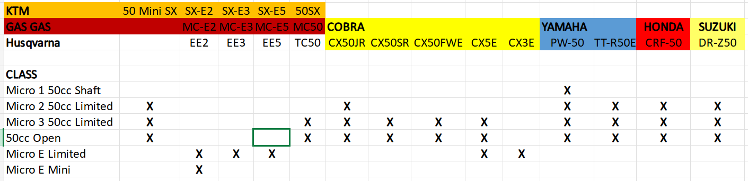

X
X
X
X

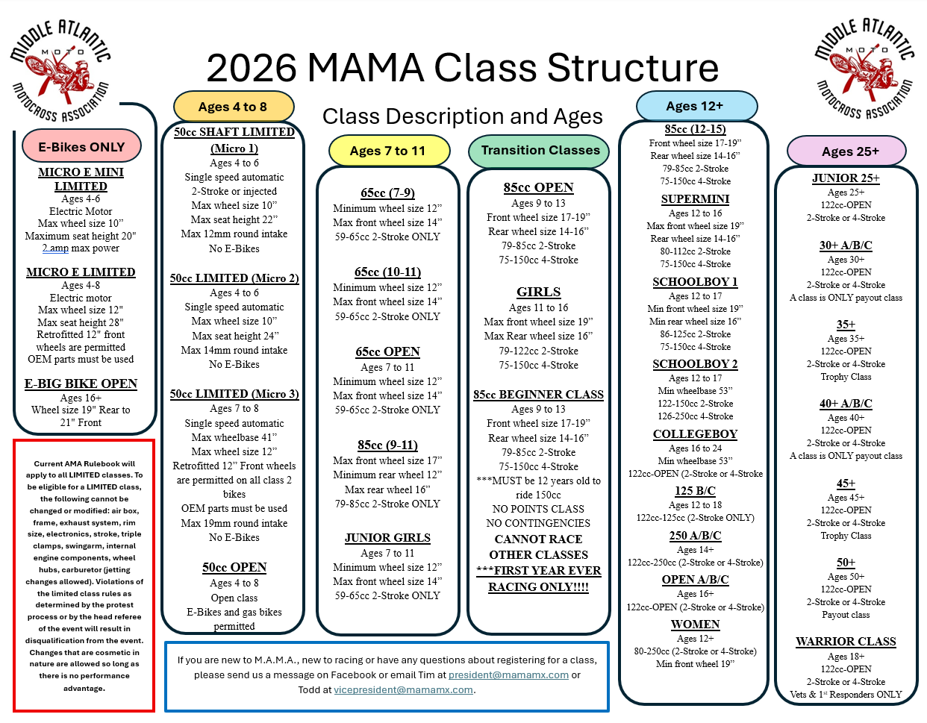

TRACK INFO

Friday Night 11:00 pm curfew - Saturday Night 10:00 pm curfew at all tracks unless otherwise determined by Track Management.
Please be responsible. As a courtesy to other members, please know where your children are after dark.
Showers at any of our tracks are not to be used to clean gear.
Sportsmanlike conduct is required at all times.
PLEASE pick up trash that you might find even if it is not yours, we would appreciate it. Thank You.
PARKING IS LIMITED - PLEASE ONLY TAKE WHAT YOU NEED
(For detailed directions, please check each track’s website)

Happy Rambers Motorcycle Club
4340 Hanover Rd.
Hanover, PA 17331
https://happyramblersmx.com

Promised Land MX
25800 Everhart Ln.
Oldtown, MD 21555
https://promisedlandmx.com

DO NOT TAKE Orleans Road or Green Ridge State forest! DO NOT take exit 68/70!***
There is a new entrance that avoids the bridge. The new entrance is marked with signs and off of the same road as it was; (Gorman Rd), but the GPS location for the entrance is now 25800 Everhart Ln. Oldtown, Md 21555.

Virginia Motorsports Park
8018 Boydton Plank Rd.
Petersburg, VA 23803
https://racevmp.com

Sleepy Hollow MX
3064 US-22
Fredericksburg, PA 17026
www.sleepyhollowmx.com

The Oak MX Park
4409 Cross Roads Blvd.
Coalport, PA 16627
https://theoakmxpark.com

Budds Creek MX Park
27963 Budds Creek Rd.
Mechanicsville, MD 20659
https://buddscreek.com

Doublin Gap MX Park
100 Reasner Ln.
Shippensburg, PA 17275
https://www,doublingap.com

DUTCHMEN MX
670 Rock Road
Pine Grove, PA 17963
https://www.dutchmenmxpark.com

Elizabeth City MX
27909 1520 Northside Rd.
Elizabeth City, NC 27909
https://ecmx.com

TOMAHAWK MX
863 Tomahawk Run Rd.
Hedgesville, WV 25427
http://www.tomahawkmx.com/

Tomahawk MX is located just on the outskirts of Martinsburg, WV in the town of Hedgesville, WV. Interstate 81 to exit 16W/Rt.9 towards Hedgesville/Berkeley Springs.
Follow Rt. 9 about 6 miles, then turn left onto Back Creek Valley Rd. (just past Tomahawk Elementary and Church)
Follow Back Creek Valley Rd. for about 2.5 miles.
Make right onto Tomahawk Run Rd. (just before Tomahawk store)
Tomahawk MX will be about 1.5 miles at bottom of hill on right.
Look for stone Tomahawk MX sign.

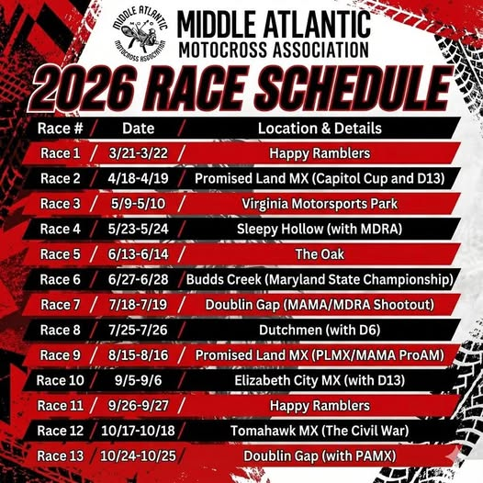

SAMPLE: MUST BE NOTARIZED

MINOR AUTHORIZATION
I, [insert PARENT name] , natural mother, AND [insert father’s name] of [insert RIDER name] , hereby give authorization to [insert name of ADULT] , to sign-up [RIDER name] for practice and racing at the MAMA Race to be held at [insert name of track] , on [insert dates] . I further give [insert name of ADULT] authorization to make any and all necessary medical decisions, including the transport of my child to the nearest medical facility if deemed necessary by medical personnel on the scene, and make any decisions necessary regarding care and treatment, by either medical personnel on the scene or at the nearest medical facility, that may be required.
[insert RIDER name] is covered by the following medical insurance: Name of insurance company
Address of insurance company
Phone number of insurance company
Name of insured party
Insurance ID #]
[insert RIDER name] has the following allergies or other special conditions:
[insert any allergies, especially those to medications, or any other medical conditions the medical personnel should be aware of such as asthma, diabetes, etc.]
Signature of Parent 1 _____________________________
Signature of Parent 2 _____________________________

SWORN AND SUBSCRIBED to before me on this _____ day of _________, 2026.
Notary Public: ______________________________
My commission expires: ______________________
Official Seal

